2024第21届中国国际文具礼品博览会

日期：2024年3月27-29日
地点：宁波国际会展中心（宁波市会展路181号）
面积：51710平方米（宁波国际会展中心H1- H8）
展商：预计1800家（上届1564家）
买家：预计35000名（上届27236名）
网址：http://www.exponingbo.com/​

组织机构：

<spanyes';font-family:宋体;mso-ascii-font-family:calibri; mso-hansi-font-family:calibri;mso-bidi-font-family:'times="" new="" roman';font-size:10.5000pt;="" mso-font-kerning:1.0000pt;"="" style="padding: 0px; margin: 0px; font-family: 微软雅黑;">指导单位：<spanyes';font-family:宋体;mso-ascii-font-family:calibri; mso-hansi-font-family:calibri;mso-bidi-font-family:'times="" new="" roman';font-size:10.5000pt;="" mso-font-kerning:1.0000pt;"="" style="padding: 0px; margin: 0px;">
<spanyes';font-family:宋体;mso-ascii-font-family:calibri; mso-hansi-font-family:calibri;mso-bidi-font-family:'times="" new="" roman';font-size:10.5000pt;="" mso-font-kerning:1.0000pt;"="" style="padding: 0px; margin: 0px; font-family: 微软雅黑;">中国国际贸易促进委员会宁波市委员会<spanyes';font-family:宋体;mso-ascii-font-family:calibri; mso-hansi-font-family:calibri;mso-bidi-font-family:'times="" new="" roman';font-size:10.5000pt;="" mso-font-kerning:1.0000pt;"="" style="padding: 0px; margin: 0px;">
<spanyes';font-family:宋体;mso-ascii-font-family:calibri; mso-hansi-font-family:calibri;mso-bidi-font-family:'times="" new="" roman';font-size:10.5000pt;="" mso-font-kerning:1.0000pt;"="" style="padding: 0px; margin: 0px; font-family: 微软雅黑;">宁海县人民政府<spanyes';font-family:宋体;mso-ascii-font-family:calibri; mso-hansi-font-family:calibri;mso-bidi-font-family:'times="" new="" roman';font-size:10.5000pt;="" mso-font-kerning:1.0000pt;"="" style="padding: 0px; margin: 0px;">
<spanyes';font-family:宋体;mso-ascii-font-family:calibri; mso-hansi-font-family:calibri;mso-bidi-font-family:'times="" new="" roman';font-size:10.5000pt;="" mso-font-kerning:1.0000pt;"="" style="padding: 0px; margin: 0px; font-family: 微软雅黑;">
<spanyes';font-family:宋体;mso-ascii-font-family:calibri; mso-hansi-font-family:calibri;mso-bidi-font-family:'times="" new="" roman';font-size:10.5000pt;="" mso-font-kerning:1.0000pt;"="" style="padding: 0px; margin: 0px;">
<spanyes';font-family:宋体;mso-ascii-font-family:calibri; mso-hansi-font-family:calibri;mso-bidi-font-family:'times="" new="" roman';font-size:10.5000pt;="" mso-font-kerning:1.0000pt;"="" style="padding: 0px; margin: 0px; font-family: 微软雅黑;">主办单位：<spanyes';font-family:宋体;mso-ascii-font-family:calibri; mso-hansi-font-family:calibri;mso-bidi-font-family:'times="" new="" roman';font-size:10.5000pt;="" mso-font-kerning:1.0000pt;"="" style="padding: 0px; margin: 0px;">
<spanyes';font-family:宋体;mso-ascii-font-family:calibri; mso-hansi-font-family:calibri;mso-bidi-font-family:'times="" new="" roman';font-size:10.5000pt;="" mso-font-kerning:1.0000pt;"="" style="padding: 0px; margin: 0px; font-family: 微软雅黑;">宁波中博国际展览有限公司<spanyes';font-family:宋体;mso-ascii-font-family:calibri; mso-hansi-font-family:calibri;mso-bidi-font-family:'times="" new="" roman';font-size:10.5000pt;="" mso-font-kerning:1.0000pt;"="" style="padding: 0px; margin: 0px;">
<spanyes';font-family:宋体;mso-ascii-font-family:calibri; mso-hansi-font-family:calibri;mso-bidi-font-family:'times="" new="" roman';font-size:10.5000pt;="" mso-font-kerning:1.0000pt;"="" style="padding: 0px; margin: 0px; font-family: 微软雅黑;">
<spanyes';font-family:宋体;mso-ascii-font-family:calibri; mso-hansi-font-family:calibri;mso-bidi-font-family:'times="" new="" roman';font-size:10.5000pt;="" mso-font-kerning:1.0000pt;"="" style="padding: 0px; margin: 0px;">
<spanyes';font-family:宋体;mso-ascii-font-family:calibri; mso-hansi-font-family:calibri;mso-bidi-font-family:'times="" new="" roman';font-size:10.5000pt;="" mso-font-kerning:1.0000pt;"="" style="padding: 0px; margin: 0px; font-family: 微软雅黑;">承办单位：<spanyes';font-family:宋体;mso-ascii-font-family:calibri; mso-hansi-font-family:calibri;mso-bidi-font-family:'times="" new="" roman';font-size:10.5000pt;="" mso-font-kerning:1.0000pt;"="" style="padding: 0px; margin: 0px;">
<spanyes';font-family:宋体;mso-ascii-font-family:calibri; mso-hansi-font-family:calibri;mso-bidi-font-family:'times="" new="" roman';font-size:10.5000pt;="" mso-font-kerning:1.0000pt;"="" style="padding: 0px; margin: 0px; font-family: 微软雅黑;">宁波中博国际展览有限公司<spanyes';font-family:宋体;mso-ascii-font-family:calibri; mso-hansi-font-family:calibri;mso-bidi-font-family:'times="" new="" roman';font-size:10.5000pt;="" mso-font-kerning:1.0000pt;"="" style="padding: 0px; margin: 0px;">
<spanyes';font-family:宋体;mso-ascii-font-family:calibri; mso-hansi-font-family:calibri;mso-bidi-font-family:'times="" new="" roman';font-size:10.5000pt;="" mso-font-kerning:1.0000pt;"="" style="padding: 0px; margin: 0px; font-family: 微软雅黑;">宁海县商务局<spanyes';font-family:宋体;mso-ascii-font-family:calibri; mso-hansi-font-family:calibri;mso-bidi-font-family:'times="" new="" roman';font-size:10.5000pt;="" mso-font-kerning:1.0000pt;"="" style="padding: 0px; margin: 0px;">
<spanyes';font-family:宋体;mso-ascii-font-family:calibri; mso-hansi-font-family:calibri;mso-bidi-font-family:'times="" new="" roman';font-size:10.5000pt;="" mso-font-kerning:1.0000pt;"="" style="padding: 0px; margin: 0px; font-family: 微软雅黑;">宁波文具行业协会<spanyes';font-family:宋体;mso-ascii-font-family:calibri; mso-hansi-font-family:calibri;mso-bidi-font-family:'times="" new="" roman';font-size:10.5000pt;="" mso-font-kerning:1.0000pt;"="" style="padding: 0px; margin: 0px;">
<spanyes';font-family:宋体;mso-ascii-font-family:calibri; mso-hansi-font-family:calibri;mso-bidi-font-family:'times="" new="" roman';font-size:10.5000pt;="" mso-font-kerning:1.0000pt;"="" style="padding: 0px; margin: 0px; font-family: 微软雅黑;">宁波东方港湾国际展览有限公司<spanyes';font-family:宋体;mso-ascii-font-family:calibri; mso-hansi-font-family:calibri;mso-bidi-font-family:'times="" new="" roman';font-size:10.5000pt;="" mso-font-kerning:1.0000pt;"="" style="padding: 0px; margin: 0px;">
<spanyes';font-family:宋体;mso-ascii-font-family:calibri; mso-hansi-font-family:calibri;mso-bidi-font-family:'times="" new="" roman';font-size:10.5000pt;="" mso-font-kerning:1.0000pt;"="" style="padding: 0px; margin: 0px; font-family: 微软雅黑;">
<spanyes';font-family:宋体;mso-ascii-font-family:calibri; mso-hansi-font-family:calibri;mso-bidi-font-family:'times="" new="" roman';font-size:10.5000pt;="" mso-font-kerning:1.0000pt;"="" style="padding: 0px; margin: 0px;">
<spanyes';font-family:宋体;mso-ascii-font-family:calibri; mso-hansi-font-family:calibri;mso-bidi-font-family:'times="" new="" roman';font-size:10.5000pt;="" mso-font-kerning:1.0000pt;"="" style="padding: 0px; margin: 0px; font-family: 微软雅黑;">支持单位：<spanyes';font-family:宋体;mso-ascii-font-family:calibri; mso-hansi-font-family:calibri;mso-bidi-font-family:'times="" new="" roman';font-size:10.5000pt;="" mso-font-kerning:1.0000pt;"="" style="padding: 0px; margin: 0px;">
<spanyes';font-family:宋体;mso-ascii-font-family:calibri; mso-hansi-font-family:calibri;mso-bidi-font-family:'times="" new="" roman';font-size:10.5000pt;="" mso-font-kerning:1.0000pt;"="" style="padding: 0px; margin: 0px; font-family: 微软雅黑;">宁波市商务局<spanyes';font-family:宋体;mso-ascii-font-family:calibri; mso-hansi-font-family:calibri;mso-bidi-font-family:'times="" new="" roman';font-size:10.5000pt;="" mso-font-kerning:1.0000pt;"="" style="padding: 0px; margin: 0px;">
<spanyes';font-family:宋体;mso-ascii-font-family:calibri; mso-hansi-font-family:calibri;mso-bidi-font-family:'times="" new="" roman';font-size:10.5000pt;="" mso-font-kerning:1.0000pt;"="" style="padding: 0px; margin: 0px; font-family: 微软雅黑;">宁波市经济和信息化局<spanyes';font-family:宋体;mso-ascii-font-family:calibri; mso-hansi-font-family:calibri;mso-bidi-font-family:'times="" new="" roman';font-size:10.5000pt;="" mso-font-kerning:1.0000pt;"="" style="padding: 0px; margin: 0px;">
<spanyes';font-family:宋体;mso-ascii-font-family:calibri; mso-hansi-font-family:calibri;mso-bidi-font-family:'times="" new="" roman';font-size:10.5000pt;="" mso-font-kerning:1.0000pt;"="" style="padding: 0px; margin: 0px; font-family: 微软雅黑;">温州市制笔协会<spanyes';font-family:宋体;mso-ascii-font-family:calibri; mso-hansi-font-family:calibri;mso-bidi-font-family:'times="" new="" roman';font-size:10.5000pt;="" mso-font-kerning:1.0000pt;"="" style="padding: 0px; margin: 0px;">
<spanyes';font-family:宋体;mso-ascii-font-family:calibri; mso-hansi-font-family:calibri;mso-bidi-font-family:'times="" new="" roman';font-size:10.5000pt;="" mso-font-kerning:1.0000pt;"="" style="padding: 0px; margin: 0px; font-family: 微软雅黑;">杭州市制笔行业协会<spanyes';font-family:宋体;mso-ascii-font-family:calibri; mso-hansi-font-family:calibri;mso-bidi-font-family:'times="" new="" roman';font-size:10.5000pt;="" mso-font-kerning:1.0000pt;"="" style="padding: 0px; margin: 0px;">
<spanyes';font-family:宋体;mso-ascii-font-family:calibri; mso-hansi-font-family:calibri;mso-bidi-font-family:'times="" new="" roman';font-size:10.5000pt;="" mso-font-kerning:1.0000pt;"="" style="padding: 0px; margin: 0px; font-family: 微软雅黑;">浙江武义县文教用品协会<spanyes';font-family:宋体;mso-ascii-font-family:calibri; mso-hansi-font-family:calibri;mso-bidi-font-family:'times="" new="" roman';font-size:10.5000pt;="" mso-font-kerning:1.0000pt;"="" style="padding: 0px; margin: 0px;">
<spanyes';font-family:宋体;mso-ascii-font-family:calibri; mso-hansi-font-family:calibri;mso-bidi-font-family:'times="" new="" roman';font-size:10.5000pt;="" mso-font-kerning:1.0000pt;"="" style="padding: 0px; margin: 0px; font-family: 微软雅黑;">义乌市文化用品行业协会<spanyes';font-family:宋体;mso-ascii-font-family:calibri; mso-hansi-font-family:calibri;mso-bidi-font-family:'times="" new="" roman';font-size:10.5000pt;="" mso-font-kerning:1.0000pt;"="" style="padding: 0px; margin: 0px;">
<spanyes';font-family:宋体;mso-ascii-font-family:calibri; mso-hansi-font-family:calibri;mso-bidi-font-family:'times="" new="" roman';font-size:10.5000pt;="" mso-font-kerning:1.0000pt;"="" style="padding: 0px; margin: 0px; font-family: 微软雅黑;">宁海县文教用品行业协会<spanyes';font-family:宋体;mso-ascii-font-family:calibri; mso-hansi-font-family:calibri;mso-bidi-font-family:'times="" new="" roman';font-size:10.5000pt;="" mso-font-kerning:1.0000pt;"="" style="padding: 0px; margin: 0px;">
<spanyes';font-family:宋体;mso-ascii-font-family:calibri; mso-hansi-font-family:calibri;mso-bidi-font-family:'times="" new="" roman';font-size:10.5000pt;="" mso-font-kerning:1.0000pt;"="" style="padding: 0px; margin: 0px; font-family: 微软雅黑;">北京文化用品行业协会<spanyes';font-family:宋体;mso-ascii-font-family:calibri; mso-hansi-font-family:calibri;mso-bidi-font-family:'times="" new="" roman';font-size:10.5000pt;="" mso-font-kerning:1.0000pt;"="" style="padding: 0px; margin: 0px;">
<spanyes';font-family:宋体;mso-ascii-font-family:calibri; mso-hansi-font-family:calibri;mso-bidi-font-family:'times="" new="" roman';font-size:10.5000pt;="" mso-font-kerning:1.0000pt;"="" style="padding: 0px; margin: 0px; font-family: 微软雅黑;">广州文具行业协会<spanyes';font-family:宋体;mso-ascii-font-family:calibri; mso-hansi-font-family:calibri;mso-bidi-font-family:'times="" new="" roman';font-size:10.5000pt;="" mso-font-kerning:1.0000pt;"="" style="padding: 0px; margin: 0px;">
<spanyes';font-family:宋体;mso-ascii-font-family:calibri; mso-hansi-font-family:calibri;mso-bidi-font-family:'times="" new="" roman';font-size:10.5000pt;="" mso-font-kerning:1.0000pt;"="" style="padding: 0px; margin: 0px; font-family: 微软雅黑;">陕西省文体用品行业协会<spanyes';font-family:宋体;mso-ascii-font-family:calibri; mso-hansi-font-family:calibri;mso-bidi-font-family:'times="" new="" roman';font-size:10.5000pt;="" mso-font-kerning:1.0000pt;"="" style="padding: 0px; margin: 0px;">
<spanyes';font-family:宋体;mso-ascii-font-family:calibri; mso-hansi-font-family:calibri;mso-bidi-font-family:'times="" new="" roman';font-size:10.5000pt;="" mso-font-kerning:1.0000pt;"="" style="padding: 0px; margin: 0px; font-family: 微软雅黑;">中国（庆元）铅笔行业协会<spanyes';font-family:宋体;mso-ascii-font-family:calibri; mso-hansi-font-family:calibri;mso-bidi-font-family:'times="" new="" roman';font-size:10.5000pt;="" mso-font-kerning:1.0000pt;"="" style="padding: 0px; margin: 0px;">
<spanyes';font-family:宋体;mso-ascii-font-family:calibri; mso-hansi-font-family:calibri;mso-bidi-font-family:'times="" new="" roman';font-size:10.5000pt;="" mso-font-kerning:1.0000pt;"="" style="padding: 0px; margin: 0px; font-family: 微软雅黑;">庆元县竹产业行业协会<spanyes';font-family:宋体;mso-ascii-font-family:calibri; mso-hansi-font-family:calibri;mso-bidi-font-family:'times="" new="" roman';font-size:10.5000pt;="" mso-font-kerning:1.0000pt;"="" style="padding: 0px; margin: 0px;">
<spanyes';font-family:宋体;mso-ascii-font-family:calibri; mso-hansi-font-family:calibri;mso-bidi-font-family:'times="" new="" roman';font-size:10.5000pt;="" mso-font-kerning:1.0000pt;"="" style="padding: 0px; margin: 0px;">山东临沂小商品城
​

上届回顾：

全球文具业界盛事——第20届中国国际文具礼品博览会（下称：宁波文具展），于2023年3月24日16时在宁波国际会展中心完美落下帷幕。本届展会历时三天，盛迎八方来客，*终统计入场总人数达33591人，专业买家28060人，参观达42453人次，再创历史新高。花开疫散，宁波文具展重回三月黄金季，启用宁波国际会展中心全部展馆（1-8号馆），满馆展出，展览面积51700平方米，设展位2360个，参展商1482家，展出数十万款展品。境外买家大量回归、到场观众优质、产品丰富新颖、订单量激增、参观满意度高等亮点*为突出，现场所展现出积极热情的融洽氛围也收获了参展人员的无数好评。

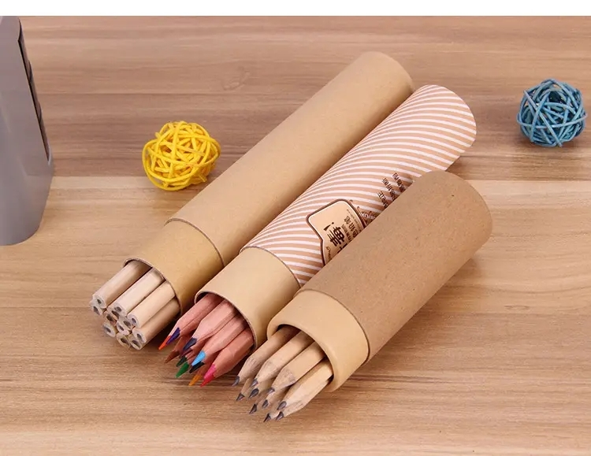

展品范围：

书写工具： 钢笔、铅笔、圆珠笔、中性笔、油性笔、记号笔、荧光笔

办公用品： 文档管理、桌面用品、财务用品、装订设备、演示及辅助用品、电脑周边、办公耗材、办公设备

纸品本册： 本册、贴纸及标签、办公用纸、纸类包装、纸类工艺品

美术画材： 绘画绘图用笔、美术颜料、绘画材质、绘画工具、装帧用品、文房四宝

学生及教学用品： 包袋类、修正类、学习工具、体育用品、教学仪器、教具、多媒体教学器材

办公生活： 劳保用品、清洁用品、办公电器、咖啡及茶饮、日常用具

设备及配件： 自动化生产设备、印刷机械、包装机械、测试设备、笔类零配件、油墨等化工原料、新材料

文创及授权： 文化创意产品、动漫IP授权、游戏IP授权、授权衍生品、文创授权、品牌授权

益智及DIY： 益智玩具、创意手工DIY产品

礼品赠品： 商务礼品、圣诞礼品、节日礼品、促销礼品、礼品文具、赠品

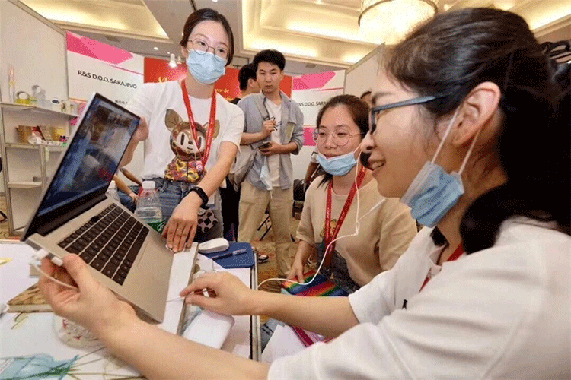

我司组展优势：

1、良好的摊位位置和价格优势。
2、境外行程和酒店食宿等安排一向优惠合理便捷，得到广大参展商和商务考察企业单位的！
3、常年操作外展经验和熟悉当地国家情况的带团人员。
4、从摊位确认到展台搭建及展览品运输和商务签证培训与补贴办理，公司一条龙的服务理念，打造展览服务行业品牌！

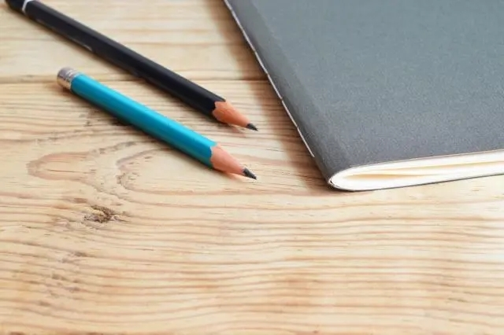

联系方式

地址：苏州 昆山市花桥镇镇中茵商务花园D区5楼800室
电话：18913292209
联系人：汪承泳
手机：18913292209
QQ：584301896
微信：18913292209
Email：584301896@qq.com

​

