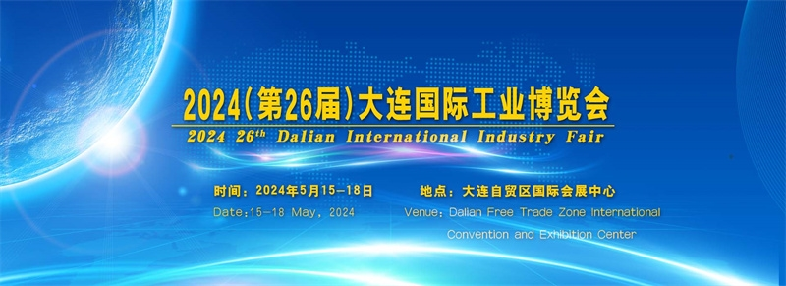

2024(第26届)大连国际工业博览会

2024(26th) Dalian International Industry Fair

时间：2024年5月15日—5月18日
Time: May 15 - May18, 2024
地点：大连自贸区国际会展中心
Venue: Dalian Free Trade Zone International Exhibition Center
(地址：大连保税区爱港路18号)

2024(第26届)大连国际工业博览会将于2024年5月15日—18日在大连自贸国际会展中心召开，上届大连国际工业博览会取得巨大成功，展商与观众均有重大收获。

2024(the 26th) Dalian International Industry Fair will be held in Dalian Free Trade International Convention and Exhibition Center from May 15 to 18, 2024, the last Dalian International Industry Fair has been a great success, exhibitors and visitors have a significant harvest.

大连金普新区是东北地区首个国家级开发区，东北地区工业的示范区、先导区，东北工业发展的龙头，体量大、技术先进、外资企业密集，马扎克、格劳博、日立、东芝、三菱、富士、松下等知名跨国公司星罗棋布，仅日韩投资工厂就近千家。

Dalian Jinpu New Area is the first national development zone in Northeast China, the demonstration area and pilot area of Northeast China's industrial development, the leader of Northeast China's industrial development, large volume, advanced technology, foreign enterprises dense, Mazak, Grob, Hitachi, Toshiba, Mitsubishi, Fuji, Panasonic and other well-known multinational companies dotted, only Japan and South Korea investment factories near a thousand.

大连地处东北亚地区的中心，国内有广阔的东北三省及内蒙古东部地区作为腹地，国外毗邻韩国、日本、朝鲜及俄罗斯远东地区，日本和韩国在大连的投资企业众多。日本在大连的投资仅次于上海和曼谷，是日本第三的海外投资城市。韩国大韩贸易振兴公社及日本神奈川政府等机构组团参展。

Dalian is located in the center of Northeast Asia, China has a vast northeast of the three provinces and the eastern region of Inner Mongolia as hinterland, foreign countries adjacent to South Korea, Japan, North Korea and the Russian Far East, Japan and South Korea in Dalian investment enterprises numerous. After Shanghai and Bangkok, Dalian is Japan's third overseas investment city. The Korea International Trade Promotion Agency of Korea and the Kanagawa Government of Japan organized delegations to participate in the exhibition.

大连国际工业博览会走过了20余年的历程，已经成为一个国际化、专业化、品牌化的知名展会，其核心竞争力在于满足参展商与参观商的需求，每年展会将吸引众多业内领军品牌到场参展，通过展会传达国内外先进技术与理念，发布前沿技术成果。与此同时，4万多高质量专业观众，将为参展商带来明确的市场需求信息和大量订单，高效推动贸易达成。

Dalian International Industry Fair has gone through more than 20 years of history, has become an international, professional, brand-oriented well-known exhibition, its core competitiveness is to meet the needs of exhibitors and visitors, the annual exhibition will attract many industry leading brands to participate in the exhibition, through the exhibition to convey advanced technology and concepts at home and abroad, the release of cutting-edge technological achievements. At the same time, more than 40,000 high-quality professional visitors will bring exhibitors clear market demand information and a large number of orders, effectively promoting trade.

​展示范围 Scope of display

机床及工模具展区：金属切削机床、钣金加工及激光切割、金属增材制造及专用机床、测量及自动化技术、刀量具、模具、机床附件等；

Machine tools and molds exhibition area: Metal cutting machine tools, sheet metal processing and laser cutting, metal additive manufacturing and special machine tools, measurement and automation technology, tool measuring tools, molds, machine tool accessories, etc.
​
机器人及工厂智能化展区：机器人及非标自动化设备、工业控制、自动化设备、仪器仪表、机械传动、低压电气等；

Robot and factory intelligent exhibition area: robot and non-standard automation equipment, industrial control, automation equipment, instruments and meters, mechanical transmission, low-voltage electrical, etc.

焊接与切割展区: 焊接切割设备、焊接材料、机器人及焊接激光系统、焊烟净化设备等;

Welding and cutting exhibition area: welding and cutting equipment, welding materials, robots and welding laser systems, welding smoke purification equipment, etc.

电子工业展区：电子应用系统、电子元器件及生产设备等；

Electronic industry exhibition area: electronic application system, electronic components and production equipment;

五金工具展区：五金机械、工具五金、机电产品、工业生产安全防护、劳保产品、紧固件、轴承等;

Hardware tools exhibition area: Hardware machinery, tool hardware, mechanical and electrical products, industrial production safety protection, labor insurance products, fasteners, bearings, etc.

铸造压铸热处理展区: 铸件、铸造设备、压铸产品、铸造材料、检测仪器、表面处理技术及设备;

Die casting Heat treatment exhibition area: castings, casting equipment, die casting products, casting materials, testing instruments, surface treatment technology and equipment;

塑料橡胶展区: 橡塑行业机械、原料及制品、3D技术、橡胶加工机械设备、塑料行业整个产业链及现代互联网新元素和未来新科技;

Plastics and rubber exhibition area: machinery, raw materials and products of rubber and plastic industry, 3D technology, rubber processing machinery and equipment, the whole industrial chain of plastics industry, new elements of modern Internet and new technologies in the future;

工业环保节能技术与设备展区：水处理技术与设备、固废处理、水泵、阀门、管件、空气净化、新风系统、工业清洗、除尘、三废回收利用，节能设备与新能源、防静电等;

Industrial environmental protection and energy saving technology and equipment exhibition area: water treatment technology and equipment, solid waste treatment, pumps, valves, pipe fittings, air purification, fresh air system, industrial cleaning, dust removal, recycling of three wastes, energy saving equipment and new energy, anti-static, etc.

工业配套服务展区：工业清洗设备、清洁剂，叉车等工业物流设备，工业原材料及工业零部件等；

Industrial supporting services exhibition area: industrial cleaning equipment, detergent, forklift and other industrial logistics equipment, industrial raw materials and industrial parts, etc.;

​观众结构 Audience structure
来源：根据现场观众调查问卷统计
Source: Statistics based on live audience survey
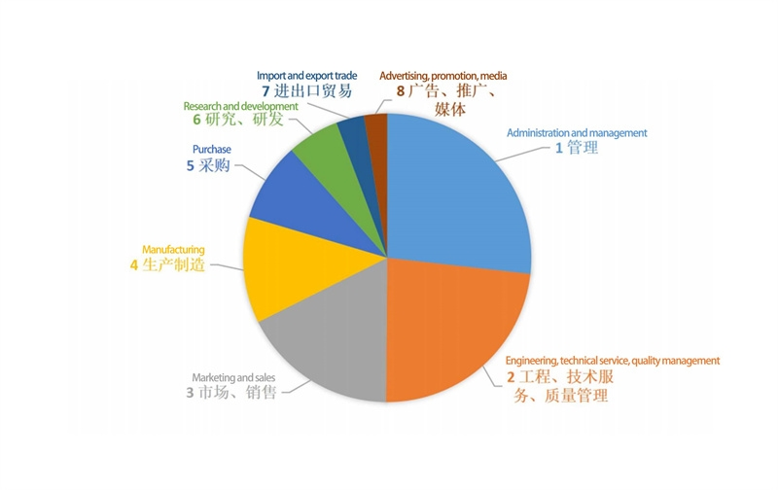

​展位预定 Booth reservation
王晓峰 13504110459
魏 娟 13998493072
吴满君 15998435367
周 英 13591356315
李 玥 18624268832
​

